The Dubbo Touch Association is once again excited to be offering a Junior Touch competition again in 2024.

The competitions will commence on **Monday 14th October 2024** **with a Double-Header SF/GF (Grand Final) to be held on Monday 16th December.**

Online registrations for the 2023 Junior Competition will be open from:

* **Monday 1st JULY 2024 UNTIL 13th August 2024 – 5PM**
* Early bird registrations close 14h July
* Team registrations close 21st July
* Player registrations close 11th August

**NO LATE REGISTRATIONS WILL BE ACCEPTED**

**DIVISIONS**

|  |  |  |  |
| --- | --- | --- | --- |
| Under 7’s | Born 2017, 2018 | 5 players on the field  Half size field  Recommended Min 7 - Max 8 players | Mixed, girls & boys teams encouraged to register however teams will play in one division. Thus is no separate division for boys, girls & mixed teams. |
| Under 9’s | Born 2015, 2016 |
| Under 11’s | Born 2013, 2014 | 6 players on the field  Full size field  Recommended Min 9 – max 12 players |
| Under 13’s | Born 2011, 2012 |
| Under 15’s | Born 2009, 2010 |

Team registrations are strongly recommended to guarantee participation in the junior competition. See Appendix 1: Team Registration Procedure (page 3).

Individual registrations – Individual players can express interest to play however will only be accepted if:

* There is enough players available in a division to create a new team and a parent is committed to take on the coach/team manager responsibility
* A registered team have availability and agree to take additional players

There is no guarantee individual player’s will be accommodated, therefore to avoid disappoint register a team, find a team to register with or EOI ASAP as will be a first in best dressed policy.

Individual players wishing to express interest see Appendix 2: Individual Players Procedure (page 6). Individual players are not to register to a team unless they have approval from the team manager. If this occurs the individual player will be removed from the team and placed on the bottom of the wait list.

**COST**

**Early Bird: $100 per player – before 5pm on Sunday 14 July 2024**

**Registration Fee: $110 per player – after 5pm Sunday 14 July 2024**

Registration fee includes an individual playing singlet, which must be worn to be able to play. No swapping of singlets is permitted.

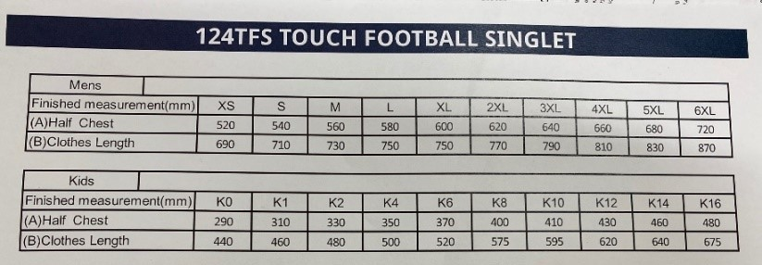

When registering you will be asked for a shirt size, please be accurate as this is the size you will receive and there will not be an opportunity to swap.

**TEAM MANAGER/COACH RESPONSIBILITIES**

The registration process is the responsibility of the **team manager & the individual** that will be participating in the competition.

DTA requires that each junior team has a designated **Manager/Coach who is responsible for organising and coordinating the team including** communicating game times and field allocations, undertaking subbing and having a basic understanding of the rules of Touch Football to provide guidance to the team.

The Manager/coach or a nominated parent **must** be in attendance at each competition game and be actively involved by standing in the sub box and managing subbing as well as player behaviour.

The Manager/coach must have a WWCC with the clearance number included on the registration when entering the team.

All Under 7 and Under 9 teams require a delegated person (this can be but doesn't have to be the team manager) **to be on the field and assist by acting as the coach** **and referee** for their team for each game e.g. in defence having players get onside, counting touches etc. Coaching tips for managers/coaches of Under 7 and 9 teams can be found at <https://www.dubbotouch.com/juniors-competition>

**DUTY TEAM REQUIREMENTS**

For Under 7’s and Under 9’s the team manager or a parent from the first team listed on the draw are required to report to the clubhouse at least 5 minutes prior to the game to collect the scoreboard and balls. The second team listed on the draw are to return the scoreboard and ball.

All Under 11, 13 and 15 teams must meet the duty requirements for the competition which includes:

* Providing **TWO** individuals each week, one willing to score and two individuals to walk the sideline. The individual refereeing can be a player or parent from the team. Duty referees are required to wear a referee shirt if badged.
* Individuals who will be doing duty must report to the clubhouse at least 5 minutes prior to the game to be ticked off as attending and to collect the scoreboard and ball. At the conclusion of the timeslot duty teams should return scoreboard and ball to the clubhouse. A failure to comply with the duty requirements will see teams lose 3 competition points.
* Teams will be required to undertake duty approximately every second week. Managers/Coaches should check the draw each week for duty allocations.

Dubbo Touch will endeavour to provide badge referees to assist duty team referees where possible however this is not guaranteed and individuals should be prepared to referee.

Prior to registering please ensure you have individual/s willing to referee. **(PLEASE BYO WHISTLE).**

**FOR MORE INFORMATION**

Please contact Michelle Roworth (Registrar) for any help or further assistance needed for registration [registrar@dubbotouch.com](mailto:registrar@dubbotouch.com)

**Appendix 1 – Team Registration ‘Step by Step Guide’**

1. NSW touch is using My Sideline as the base for all registration details for Touch comps. Click on the following link and go to Register – top right hand of the screen.

<https://touchfootball.com.au/sa/play/>

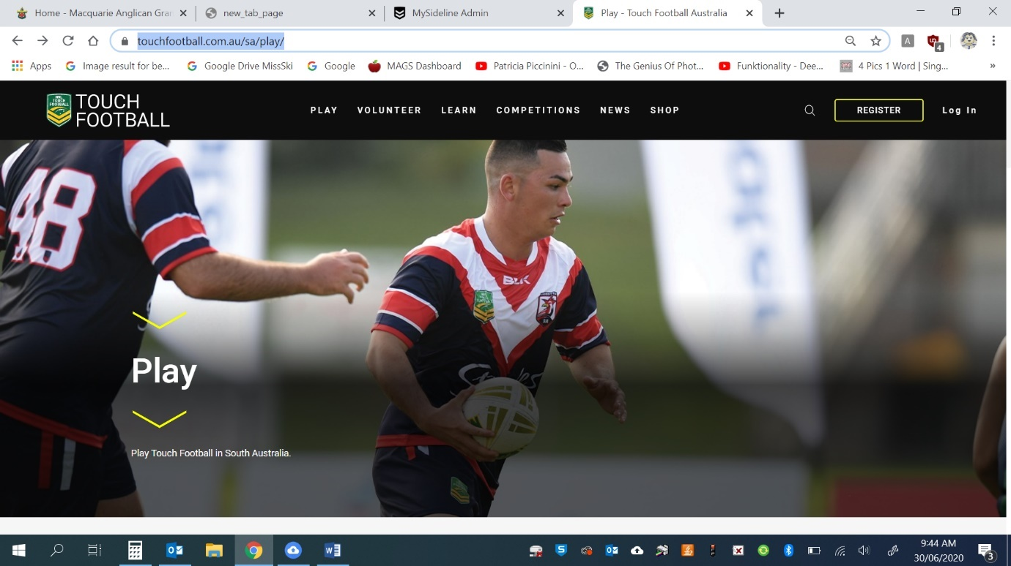

1. Once you have opened the Register page you will be given 4 options.

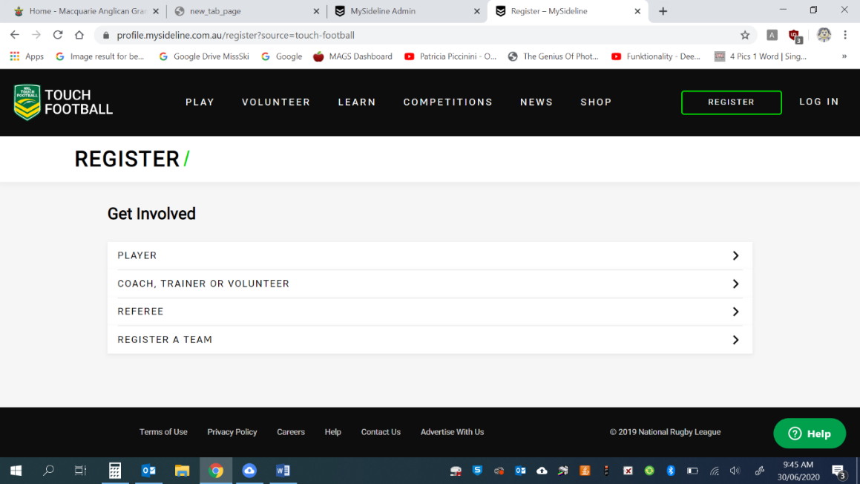

1. For TEAM REGISTRATION Find the Dubbo competition you wish to enter

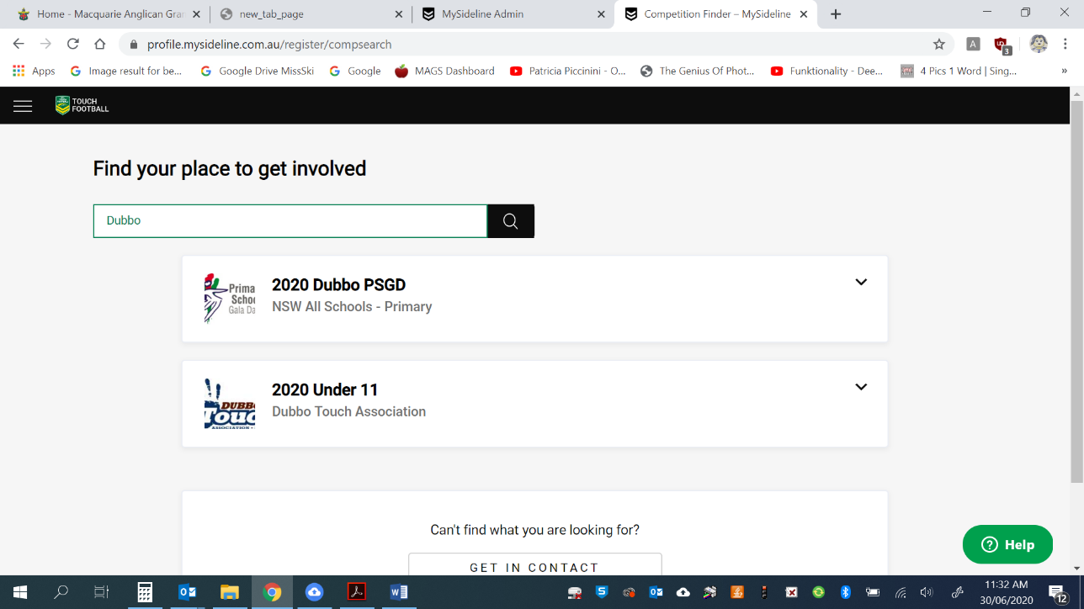

* You will need to create a NRL account to proceed - this is a simple process and it will give you the option to create a NRL account.

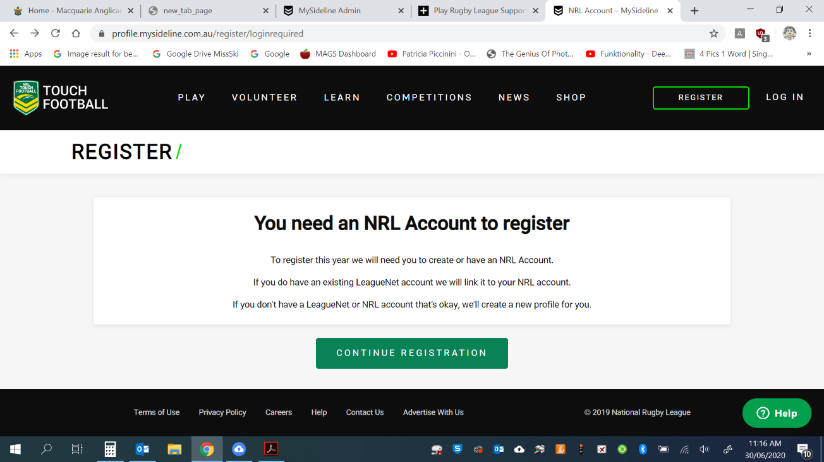

1. Enter in team details – remember team shirts will be supplied for Juniors.

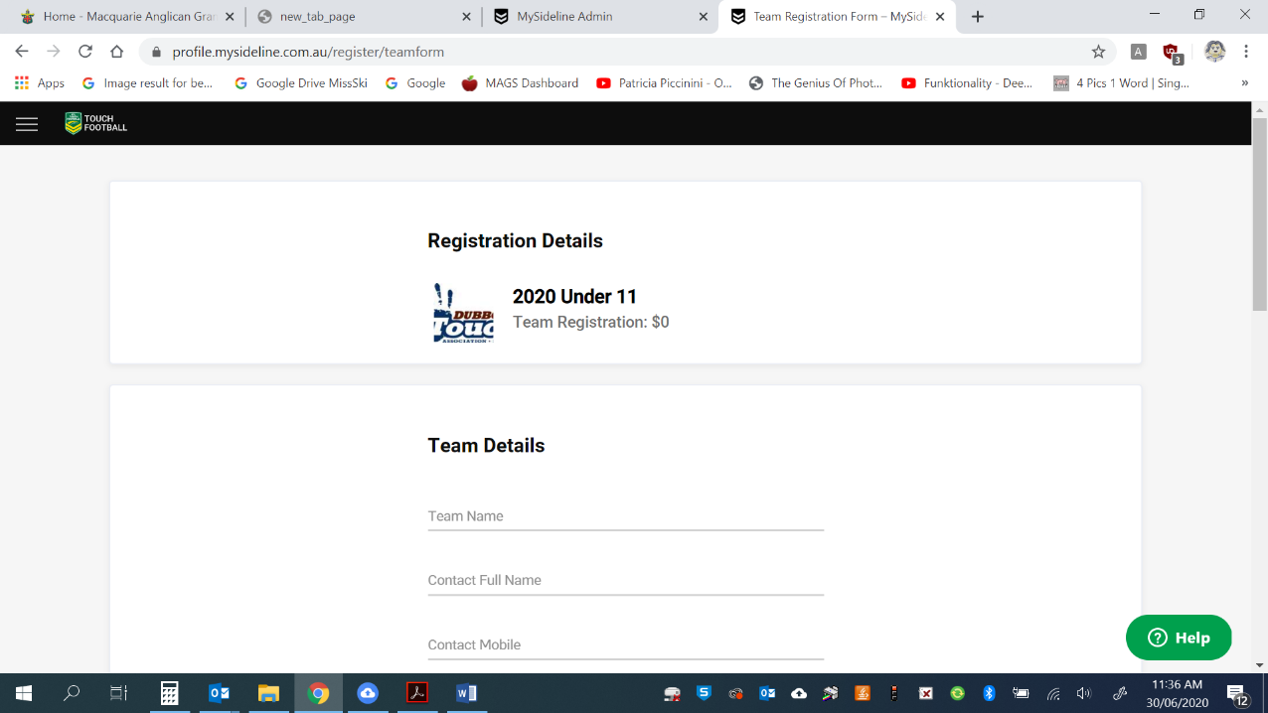

* You will have the option to invite platers to register in your team via email. This step can be done after your team is set up if you prefer

1. 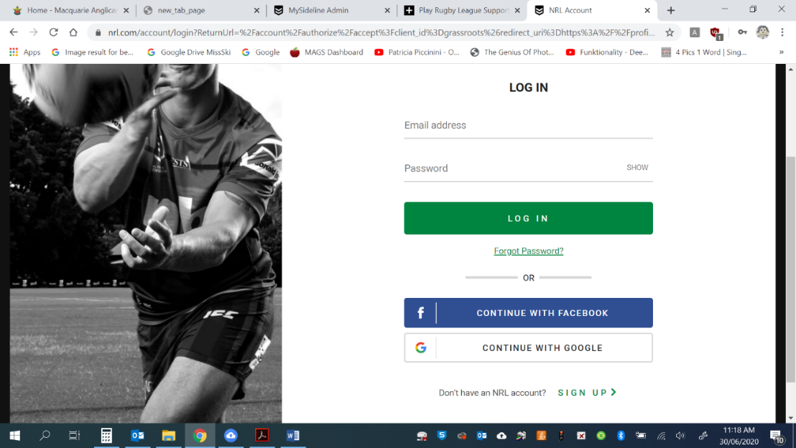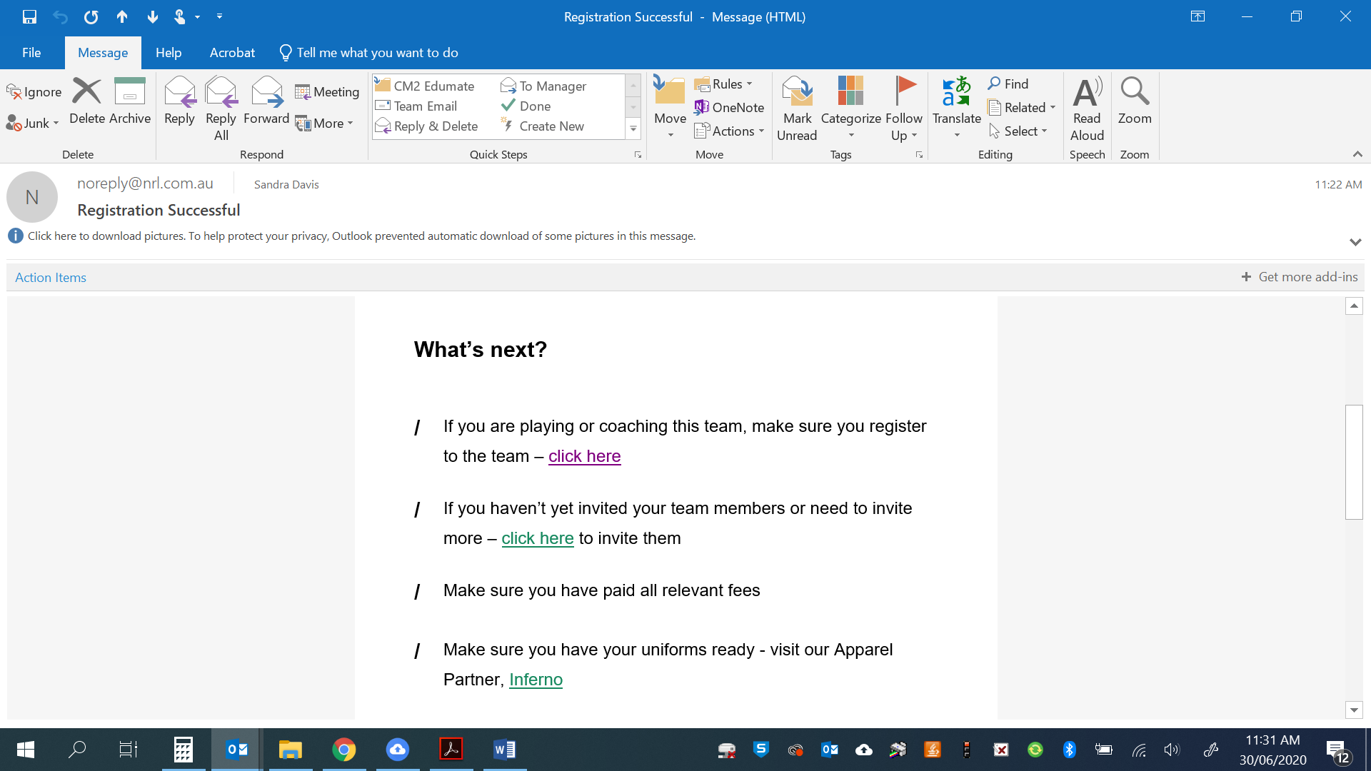You will then recive a conformation email – you are then asked to add information to your profile including your WWCC number.
2. Your players will receive the following email – this will take them through the player registration

* Individuals will need to create a NRL account to proceed - this is a simple process and it will give you the option to create a NRL account.

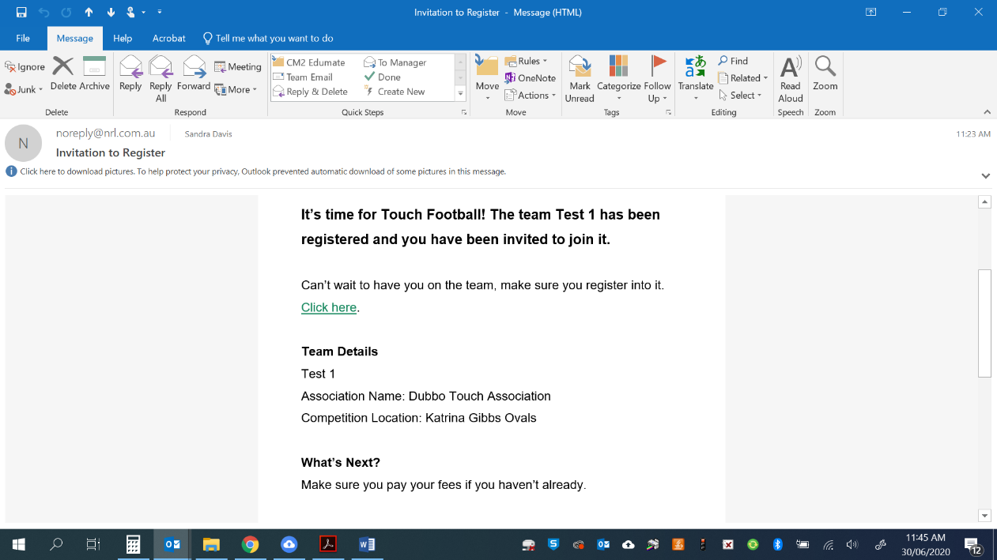

1. 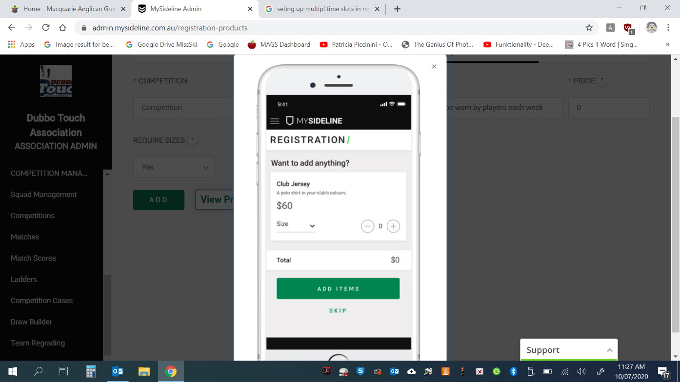After registration you will be asked if you would like to add anything, this is where you requited to select a singlet size. There is not cost for this – the image is just an example.

**Appendix 2 – Individual Player Expression of Interest ‘Step by Step Guide’**

*Please note there is no guarantee that individual players will be able to be accommodated in a team to participate in the Junior Touch Competition.*

1. Send an email to [registrar@dubbotouch.com](mailto:registrar@dubbotouch.com) with the following information:
   * + Child’s Full Name
     + Child’s Date of Birth
     + School Child Attends
     + Parent’s Full name
     + Parent’s contact number
     + Parent’s email
     + Indication of whether parent would be willing to manage/coach a team if enough players to form a new team
2. The individual player’s parent will be sent an email with the link to register. Please note there is no guarantee the players will be accommodated in a team.
3. The Registrar and Junior Competition Coordinator will liaise with the managers of registered teams to see if any availability or determine whether there are enough individual registrations and a parent willing to manage/coach in order to form a new team.
4. The Registrar and/or Junior Competition Coordinator will make contact with the parent to confirm whether the individual has been able to be accommodate in a team or not.
5. If the individual player cannot be accommodated in a team a full refund will be provided by Dubbo Touch however please note Active Kids Vouchers are unable to be refunded.

|  |  |  |
| --- | --- | --- |
| **Round** | **Date** | **Comment** |
| 1 | 14 October 2024 |  |
| 2 | 21 October 2024 |  |
| 3 | 28 October 2024 |  |
| 4 | 4 November 2024 |  |
| 5 | 11 November 2024 |  |
| 6 | 18 November 2024 |  |
| 7 | 2 December 2024 |  |
| 8 | 9 December 2024 |  |
| 9 | 16 December 2024 | Finals Format:  Major Semi 1 v 2 (Winner straight to GF, Loser will play winner of minor semi)  Minor Semi 3 v 4 (Winner to play loser of major semi and loser is out)  Grand Finals U11’s – U15’s and Presentations |

**2024 JUNIOR TOUCH COMPETITION CALENDAR**