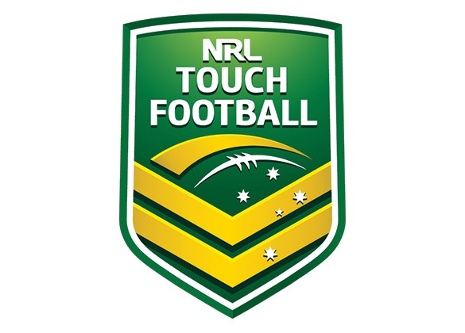
TOUCH FOOTBALL – CODE OF CONDUCT

The Touch Football Australia Code of Conduct reflects our support and implementation of the sport industry principles and values outlined in the Australian Sports Commission’s The Essence of Australian Sport –principles of fairness, respect, responsibility and safety. This Code aims to ensure our core values, good reputation and positive behaviours and attitudes are maintained and that everyone involved in our sport is aware of his or her legal and ethical rights and responsibilities.
This Code of Conduct applies to all individuals and entities involved with Touch Football Australia. The Core Code must be observed by all without exception.
The Core Code
- Operate within the rules and spirit of your sport, promoting fair play over winning at any cost.
- Encourage and support opportunities for people to learn appropriate behaviours and skills.
- Support opportunities for participation in all aspects of the sport.
- Treat each person as an individual.
- Display control and courtesy to all involved with the sport.
- Respect the rights and worth of every person regardless of their gender, ability, cultural background or religion.
- Respect the decisions of officials, coaches and administrators in the conduct of the sport.
- Wherever practical, avoid unaccompanied and unobserved one-on-one activity (when in a supervisory capacity or where a power imbalance will exist) with people under the age of 18 years.
- Adopt appropriate and responsible behaviour in all interactions.
- Adopt responsible behaviour in relation to alcohol and other drugs.
- Act with integrity and objectivity, and accept responsibility for your decisions and actions.
- Ensure your decisions and actions contribute to a safe environment.
- Ensure your decisions and actions contribute to a harassment free environment.
- Do not tolerate harmful or abusive behaviours.
Athletes Code
- Give your best at all times.
- Participate for your own enjoyment and benefit.
- refrain from any behaviour that may bring Touch Football Australia, a member association or an affiliated club into disrepute • exhibit exemplary sportsmanship at all times
Coaches Code
- Place the safety and welfare of athletes above all else
- Promote respect for the ability of your opponents, referees and all officials
- Help each person (athlete, official etc) reach their potential - respect the talent, developmental stage and goals of each person and compliment and encourage with positive and supportive feedback
- Any physical contact with a person should be appropriate to the situation and necessary for the person’s skill development
- Commit to providing a quality service to your athletes
- Embrace your position as a positive role model for your sport and athletes
- Be honest and do not allow your qualifications to be misrepresented
Officials Code
- Place the safety and welfare of the athletes above all else.
- Be consistent and impartial when making decisions.
- Address unsporting behaviour and promote respect for all people.
- Avoid any situation which may lead to a conflict in interest.

Administrator Code

- Act honestly, in good faith and in the best interests of the sport as a whole.
- Ensure that any information acquired or advantage gained from the position is not used improperly.
- Conduct your responsibilities with due care, competence and diligence.
- Do not allow prejudice, conflict of interest or bias to affect your objectivity.
Parents Code
- Encourage children to participate and have fun.
- Provide a model of good sportsmanship for your child to copy.
- Focus on the child’s effort and performance rather than winning or losing.
- Never ridicule or yell at a child for making a mistake or losing a competition.
Spectators Code
- Respect the performances and efforts of all people.
- Reject the use of violence in any form, whether it is by spectators, coaches, officials or athletes.

